Sprint – 2 Testcases

|  |  |
| --- | --- |
| Team ID | PNT2022TMID47734 |
| Project Name | Project - Project - VirtualEye - Life Guard for Swimming Pools to Detect Active Drowning |

**Case1:** Prediction page

This page helps in showcasing our demo of the project. On clicking the button for demo we can get the results in the project.

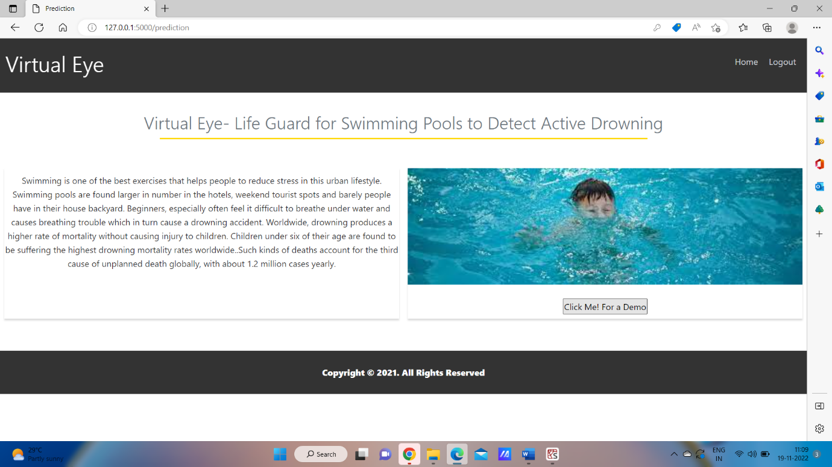

**Case2:** Logout page

In this page we can come out of our application by safely logging off our account.

